Absolute path: /home/330/Assign1 -for the direct path from the bottom up

Relative path: /300/Assign1 -for when you’re in the present work directory (pwd)

~ -for the home directory

& -run something in the background

Links: Hard link cant link to directory, cant cross file system. Soft link can do both

Pwd -prints absolute path to current directory

Which -searches for executables

Man -manual for stuff

Hton -server port

Ls>test.txt -will write the contents of ls to test.txt

Awk’{print NR, $0}’ file -prints the number of records in the front of each record

Sed -n -e ‘4 p’ file -prints the 4th line of file in sed

Echo $HOME - absolute path to home directory

Echo $PATH -shows all paths

ECHO $USER -shows username

number of record -NR is in awk

number of fields -NF in awk

FS -field separator

chgrp -changes group permissions

chmod -can add or remove permissions

chown -change owner permissions

socket -creates a new socket as endpoints to communication links

ps -displays info about a selection of the active processes

$ -endline anchor

< -input redirection

> -output redirection

| -pipe the data into a program

/> -ending word anchor

Tcp is connection oriented and has guaranteed delivery

UDP is datagram oriented

!-3 -command from 3 commands ago

*wildcard -can be 0 to many characters

? wildcard -exactly 1 value

Bind -sets up address

sed -n -e 's/help/cool/' file -replaces help with cool

sed -n -e ‘3 p’ input -shows only line 3

sed -n -e ‘$ p’ input -shows only last line

!ec -runs the last command that starts with ec

Sendto -send datagram to a socket

Recvform -receives datagram from socket and returns the bytes

Inet_ntoa -convert host address to a string

Listen -marks a connection mode socket

Getaddrinfo -translation from asni host name to an address

Physical, data link, network, transport, session, presentation, application -7 layers of networking

!! -last command

Awk -F: -change the field separator

Command < file -file reads in the commands

Inet_aton -converts IPv4 to binary and stores it in a struct

DNS -internet phonebook that keeps track of IPs

Rm -r -remove a not empty directory

/< -beginning word anchor

^ -new line anchor

Fork returns 0 for child and pid of child for parent

Bg -places jobs into the background

Fg -places jobs from the background to foreground

Read: ssize_t read (int fd, void *buf, size_t count). Reads up to count bytes from fd into buf. Returns positive number for bytes read and 0 for finished reading. Anything else is an error

Write: ssize_t write (int fd, void *buf, size_t count). writes up to count bytes from fd into buf. Returns positive number for bytes written and 0 for finished. Anything else is an error

131.156.0.0/16 -first n bit of IP number, written as /n. 8-class A, 16-class B…

Ntohl(), htonl() -converts 32 bit values

Ntohs(), htons() -converts 16 bit values

*ai_addr -socket address when doing addrinfo

Sed parameter “-i” makes permeant changes

Sed i inserts a line before, a inserts after, and c makes changes, d deletes it

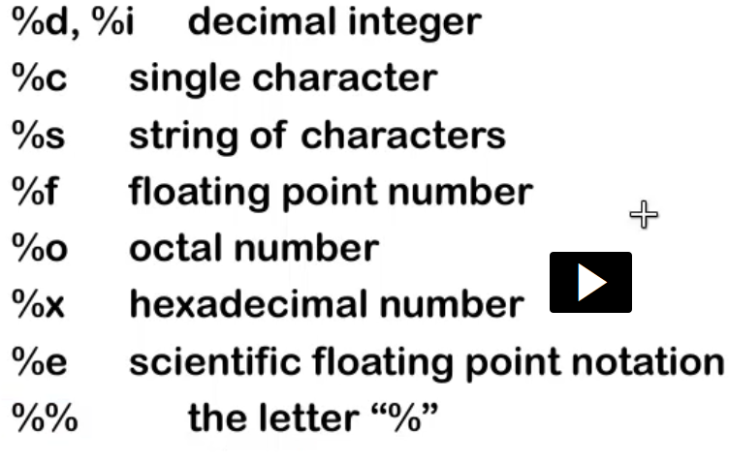

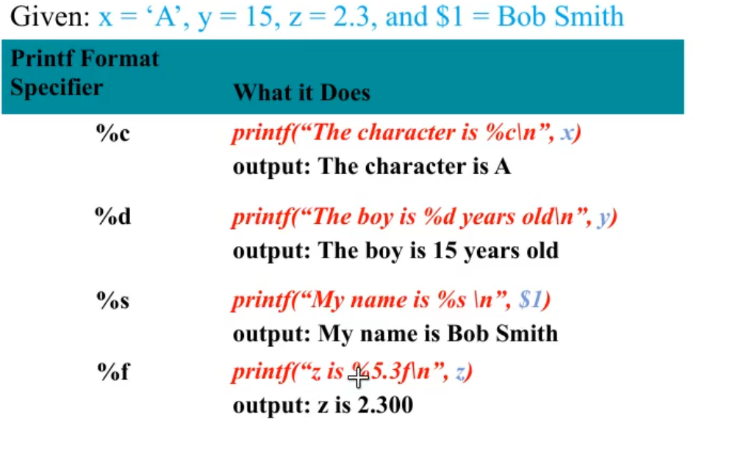

Listen() does not block

TCP uses SOCK_STREAM

Backlog specifies length of incoming connection queue

NC is netcat